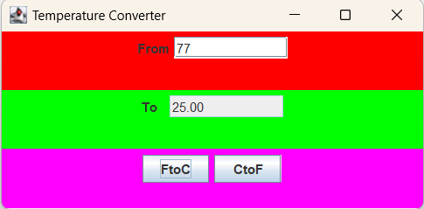

package as11;

public class TestJFrameExt {
public static void main(String[] args)
{
// Create the temperature converter application
JFrameExt converter = new JFrameExt();
}
}

